MONISHA.DUSANAPUDI
Phase 2 Report: Org Setup & Configuration
Non-Profit Donation & Volunteer Management

Objective: The goal of Phase 2 was to provision a Salesforce organization and establish the complete foundational configuration. This includes setting company-wide standards, building a multi-layered security model, and preparing the environment for custom development.
Dev Org Setup & Salesforce Editions:
- A new, permanent Salesforce Developer Edition organization was created and provisioned
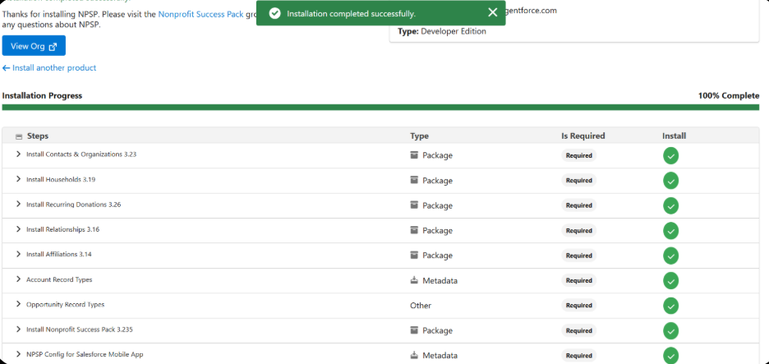
Company Profile Setup:
- Navigated to Setup > Company Information and configured the core company profile. The default timezone was set to (GMT+05:30) India Standard Time (Asia/Kolkata) and the currency locale was set to English (India) - INR.
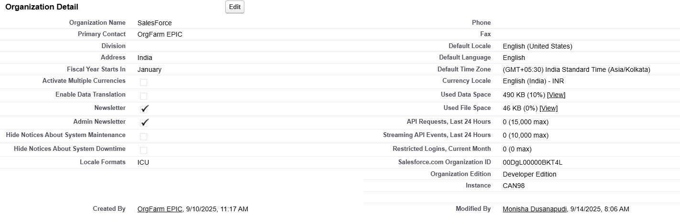
Business Hours, Holidays & Fiscal Year Settings
  - Fiscal Year: The standard fiscal year setting (January - December) was reviewed and deemed appropriate for the initial needs of the non-profit model.
  - Business Hours & Holidays: The setup for specific business hours and holidays was noted but deferred.
User Setup, Licenses, Profiles & Roles
- Action Taken: A comprehensive user and security hierarchy was established.
  - Roles: A three-tier Role Hierarchy was created: CEO > Director of Operations > Volunteer Coordinator. This establishes a data visibility structure based on an organizational chart.
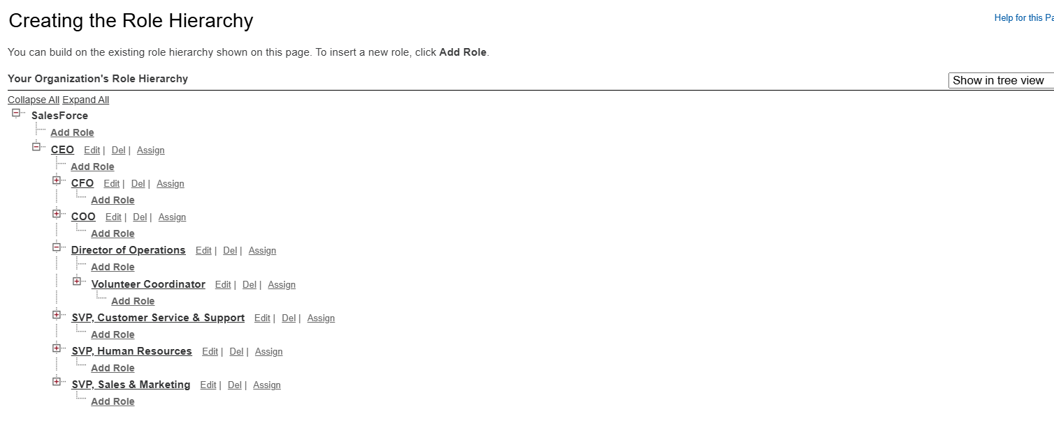
  - User Setup & Licenses: A test user, "Valerie Coordinator," was created using a Salesforce license.
  - Profiles: The user was assigned the Standard User Profile.
OWD (Org-Wide Defaults) & Sharing Rules
  - OWD: The Org-Wide Defaults were set to Private for the Account, Contact, and Opportunity objects.
  - Sharing Rules: The concept of sharing rules as exceptions to OWD was reviewed, but no rules were created in this initial phase.
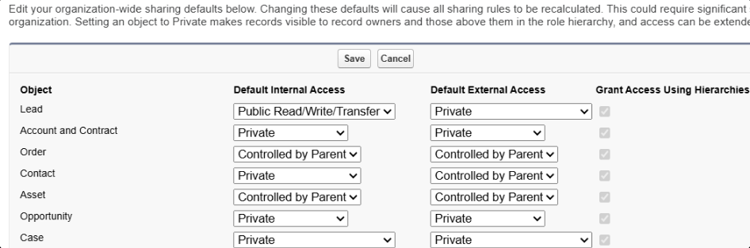
Login Access Policies
- Action Taken: The policy allowing "Administrators Can Log in as Any User" was enabled.
Sandbox Usage & Deployment Basics
- For this project, all development and configuration are being performed directly within the Developer Edition org.

TESTING THIS PHASE
Verification & Testing:
To validate the successful implementation of the security model, a verification test was performed:
- As the System Administrator, a new Contact record ("John Donor") was created.
- Using the "Login As" feature, a session was initiated as the lower-level user, "Valerie Coordinator."
- An attempt was made to view the "All Contacts" list.
Test Result: The "John Donor" record was not visible to Valerie Coordinator. This result successfully confirms that the Private Org-Wide Default setting is working as designed, preventing a user from accessing records they do not own.

